 | Integrated Management System | Approval
 | Integrated Management System | Environmental Manager
 | Best Operating Practice | Doc No: IAP BOP-05
 | Best Operating Practice | Issue Date: 30/04/2010 | Rev: 0
TITLE: | IAP Treatment Specifications: Chromoleana

IAP Species: | Chromoleana - Chromoleana odorata  Triffid weed, Paraffienbos, usandanezwe, uhalahala, uboyana |  |  |  |  | Cara Category: |  |  |  |  |  | 1  Prohibited
Foliage: | Deciduous perennial |  | Growth form: | Woody shrub |  | Poisonous / Precautions: |  |  |  |  |  | Poisonous to livestock
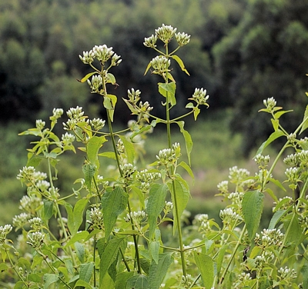  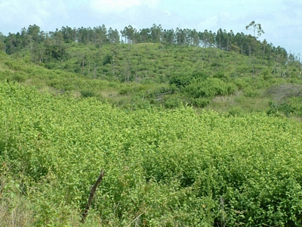  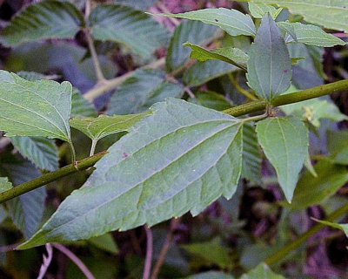  Pictures downloaded from http://www.agis.agric.za/wip/ herbarium |  |  |  |  |  | Description:  Small shrub which can take on a scrambling form in dense thickets; Leaves: light green, often yellowish, ovate to triangular, three-veined from the base; smell strongly of turpentine or paraffin when crushed. Flowers: white or pale blue at end of branch. Fruits: straw-coloured, bristly ± 5 mm long.
 |  |  |  |  |  | Flowering: | J | F | M | A | M |  | J |  | J | A | S | O | N | D
Important aspects of Biology:
Seeds are wind dispersed and germinate easily. One plant can produce up to 1 million viable seeds. Once established it can completely smother and suppress indigenous vegetation. Degraded (overgrazed/disturbed) areas are particularly susceptible to invasion; however it is also capable of invading undisturbed areas. It cannot survive frost which has been a major factor limiting its spread inland. It is highly flammable and alters the fire ecology of the vegetation type it invades, particularly indigenous forest.
Planning:
Chromoleana is easily killed with herbicide; however the high seed production, spread and rapid growth mean that regular followups are necessary. Fire is an essential tool in Chromoleana control, particularly for large dense infestations, it suppresses growth and reduces the number of chemical followups required. With Chromoleana in particular, it is essential that post canopy weed control in commercial cmpts takes place adjacent to open areas where Chromoleana has been treated – failure to do this will prolong the control time necessary.
Mondi Prescribed Treatments:
Experience in Zululand has shown that using a cut stump as an initial treatment and foliar spray’s as followup method is most effective.
Foliar Spray: Ensure good droplet distribution.
Cut Stump: Stumps need to be cut as low as possible not more than 5cm.
Hand pull: Only feasible in Zululand on sandy soils if young seedlings and low densities.

Herbicide prescribed: |  | Trade name |  |  | Rate: |  |  |  |  |  |  |  |  | Application method
Metsulfuron-methly 500g/kg EC |  | Nicanor |  |  | 3g per 10ℓ of water (include dye) |  |  |  |  |  |  |  |  | Foliar
Metsulfuron-methly 600g/kg EC |  | Brush-off, Climax |  |  | 2.5g per 10ℓ of water (include dye) |  |  |  |  |  |  |  |  | Foliar
Floroxypyr/picloram 80/80 g/ℓ ME |  | Plenum |  |  | 75ml in 10ℓ of water (include wetter and dye) |  |  |  |  |  |  |  |  | Foliar & Foliar
Triclopyr 240 g/ℓ EC |  | Ranger |  |  | 75ml in 10ℓ of water (include dye) |  |  |  |  |  |  |  |  | Foliar
Triclopyr 480 g/ℓ EC |  | Garlon  Triclon  Viroaxe |  |  | 37.5ml in 10ℓ of water (include dye and wetter) |  |  |  |  |  |  |  |  | Foliar
Imazapyr 100g/ℓ SL |  | Chopper  Hatchet  Eco-Imazapyr |  |  | 200ml in 10ℓ of water |  |  |  |  |  |  |  |  | Cut stump
Triclopyr 360 g/ℓ SL |  | Timbrel |  |  | 200ml in 10ℓ of water (include a dye) |  |  |  |  |  |  |  |  | Cut stump

*References can be found in the IAP Herbicide Treatment Doc ETT-02 and IAP Management in Conservation Areas Doc EG-01.

