Hack and squirt / Cut-stump  Stem Diameter 0-10cm |  |  |  | Chemical
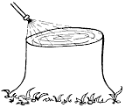  Description | Labour intensive method of treating the cut surfaces of the stems with systemic herbicide to kill the target plant.
 | Treatment with herbicide must be done within 20 minutes of the stems being cut.
 | Stem to be cut as low to the ground as possible, not greater than ankle (safety boot) height. The cut should provide as flat a surface as possible. In dense “jungle wattle” situation, slanted cuts also pose a safety risk to workers.
 | A hand held sprayer should be used to apply the herbicide mixture to the sapwood region of freshly cut-stump surfaces (i.e. before the surfaces dry) using a low pressure applicator Each person in the team must have their own herbicide container to ensure that the herbicide is applied to each stem as soon after cutting as possible.
Tools | Best Practice |  | Most commonly used
Tools | Bow-saw or Pruning saw  Stem diameter 3-10cm |  | Slasher / Bush Knife / Calemba
Tools | Long handled lopper  Stem diameter 0-3cm |  | Paint brush & tin
Tools | Low pressure hand held sprayer |  | Plastic bottle with sponge lid
Potential problems | Slanted cut surface showing multiple cut marks | Often the result of using a blunt slasher/bush knife/calemba. Multiple cuts are required to get through the stem and the resulting stump tends to be slanted/pointed and the bark “pops” from the stem. Herbicide then runs off the cut surface before being taken up by the plant decreasing the efficacy.
Potential problems | Multi-stem plants | Multi-stemmed coppiced plants are generally difficult to kill and pose a problem as it can be difficult to cut the stem low to the ground. Each stem should be cut so as to provide a flat surface (not slanted) to ensure maximum herbicide penetration into the plant.
Potential problems | Stump cut too high | Stumps higher than ankle height are too high. Stump height affects the herbicide efficacy. If the stump is cut too high, herbicide may not reach the roots before translocation stops, this then result in “feathering” or coppicing.
Potential problems | Coppicing of some stems and not others after treatment | This happens when each worker does not have their own herbicide applicator and stumps are missed in dense vegetation. OR  Incorrect application on the stump.
Potential problems | Herbicide splashing off cut surface | If using a hand held pressurised/pump applicator - splashing indicates that the pressure is too high, applicator should be at minimal pressure when doing stump treatments to minimise splashing. When treating thin stems ensure nozzle is set to solid stream and not “cone” spray.
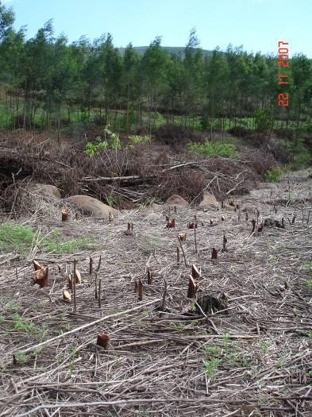
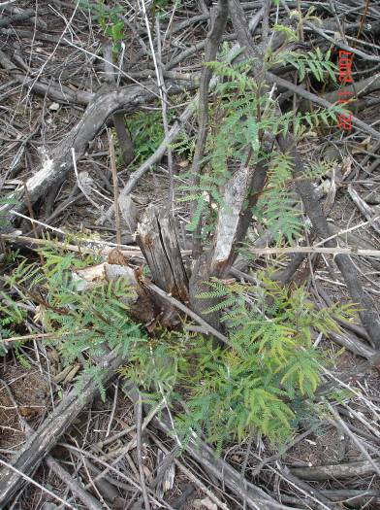
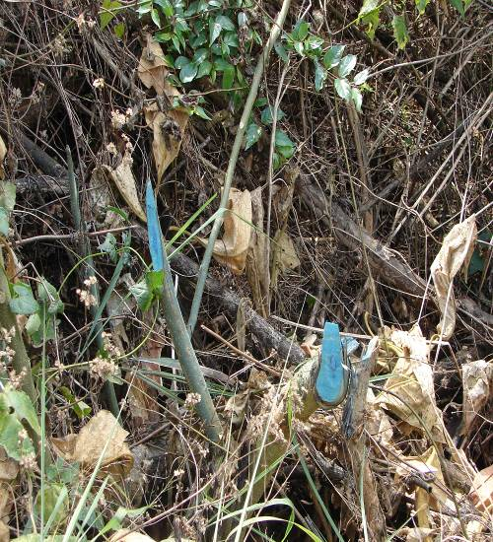
Cuts are low to the ground, however the slant reduces herbicide efficacy and could pose a safety risk
Multi-stem, classic calemba cuts, slant reduces herbicide efficacy, results in feathering
Classic calemba cuts, slant reduces herbicide efficacy,

Frill  Stem diameter >10cm |  |  |  | Chemical
Description  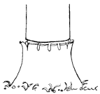 | Labour intensive method of treating the stem of a thin barked target plant with systemic herbicide.
 | The cut must go through the outer layers (phloem & cambium) to the wood surface in order to be effective.
 | The downward slanting frill cuts should form a continuous ring around the stem that will retain the herbicide when applied. The frill should be as close to the ground as possible.
 | The cuts should be deep enough to expose the cambium layer; however they should not be too deep as they will then stop translation making the herbicide ineffective.
 | Treatment with herbicide must be done within 15 minutes of the frilling process. Using a low pressure handheld-sprayer, the herbicide should be applied to the frill cut with a solid stream, going around the stem’s circumference twice.
 | The person who cuts the stem must apply the herbicide.
Tools | Best Practice |  | Most commonly used
Tools | Hatchet |  | Slasher / Bush Knife / Calemba
Tools | Low pressure hand held sprayer |  | Paint bush
Potential problems | Multi stem plants | Each coppice stem OR the common stem below the fork must be treated. It is difficult to treat each coppice stem completely when close together. Should the plant have more than 3 coppice stems, or the common stem is inaccessible, a cut stump application would be more effective.
Potential problems | Frill cut too high | If the frill is too high, the herbicide will not be effective as it is often diluted to sub lethal levels by the plants in-situ water.
Potential problems | Herbicide splashing | Splashing indicates that the pressure is too high, applicator should be at low pressure when doing frill treatments to minimise splashing. Ensure nozzle is set to solid stream and not cone spray.
Potential problems | Cut depth | Shallow cuts do not allow the herbicide to come into contact with the cambium. Deep cuts will stop translocation and hinder herbicide efficiency.
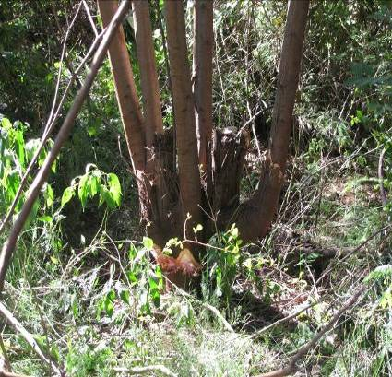
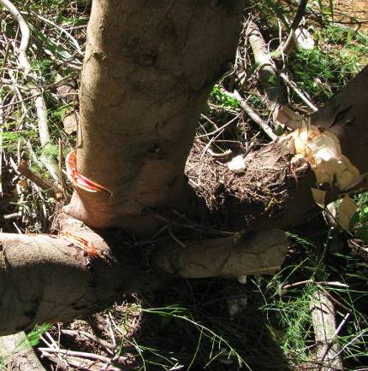
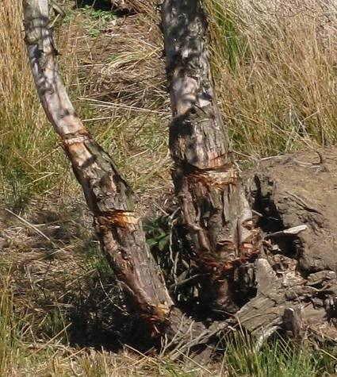
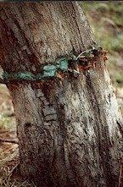
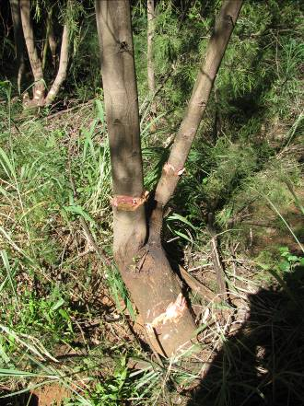
Correct treatment of a coppice stem, the common stem has been treated. However, for this number of coppice stems, a cut stump might have been more effective.
Incorrect frill. The cuts do not go completely around the stem.
1
2
3
An example of a correct frill, low down, deep enough cut able to hold the herbicide and goes around the circumference of the stem.
Initial treatment was a narrow ringbark or poor frill. The cut would not have held the herbicide for sufficient period and is too high.
Multiple treatments to same tree – a poor ring bark and some frills. The ring bark width is too narrow. The initial frill should have been as low as possible to the base of the stem
Incorrect treatment of a coppice stem, the common stem frill will stop the herbicide from the individual stem frills above it from reaching the roots
✗
✗
✓

Ring Bark  Stem diameter >10cm |  |  |  | Manual
Description  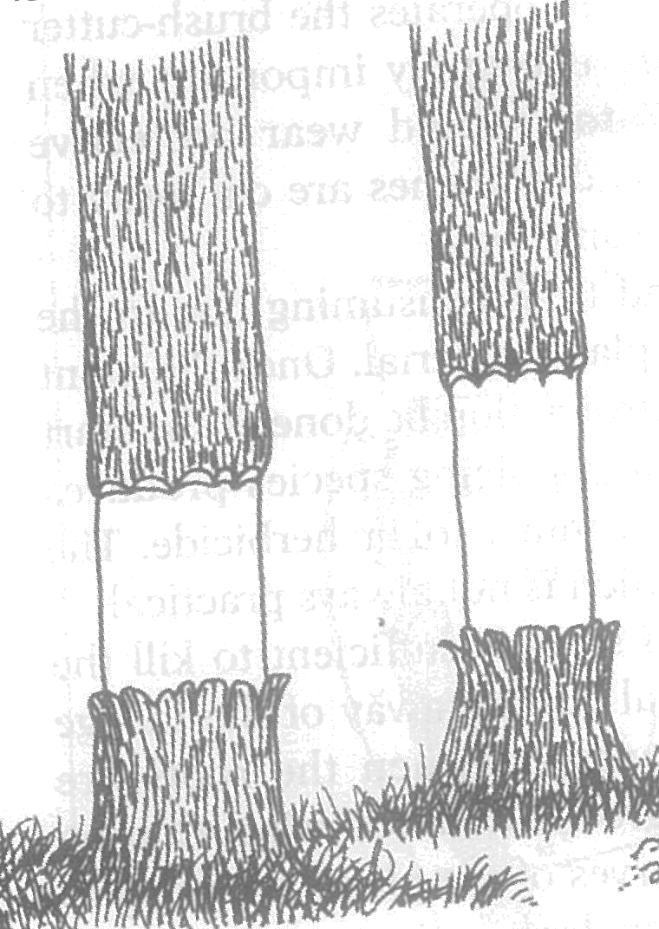 | Labour intensive method of killing thick bark trees (e.g. Pine) by removing the bark and cambium connection between the roots and leaves. Normally not suitable for species that coppice.
 | The bottom cut should be made first, followed by the top cut a hatchet length (0.5m) above this. The bark in-between is peeled away.
 | The cambium and phloem layers must be thoroughly cleaned off the stem.
 | If the “ring” is too narrow, any remaining phloem/cambium will regrow and result in the recovery of the plant.
 | Generally not suitable for coppicing species as many will coppice from below the bottom cut.
Tools | Best Practice |  | Most commonly used
Tools | Hatchet |  | Slasher / Bush Knife / Calemba
Potential problems | Varying effectiveness | Poorly supervised and poorly trained workers will result in variable “kill” for target plants.
Potential problems | Multistem species | Not suitable for multistem plants – difficult to get an effective ring around all stems.
Potential problems | Cambium left behind | If the ring is too narrow or the bark does not strip easily, it is very likely that small strips of cambium will regrow which will result in the tree recovering, similar to a wound on a human which eventually heals leaving a scar.

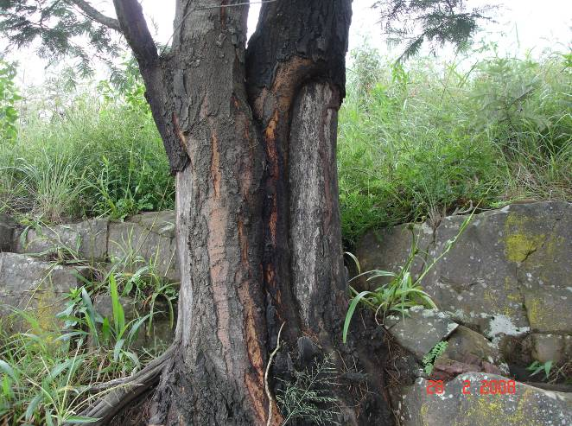
Old ring bark scar
A mature wattle which has survived previous ring bark attempts. A frill or cut stump application would be more suitable.
Bark regrowth

Strip Bark  Stem diameter >10cm |  |  |  | Manual
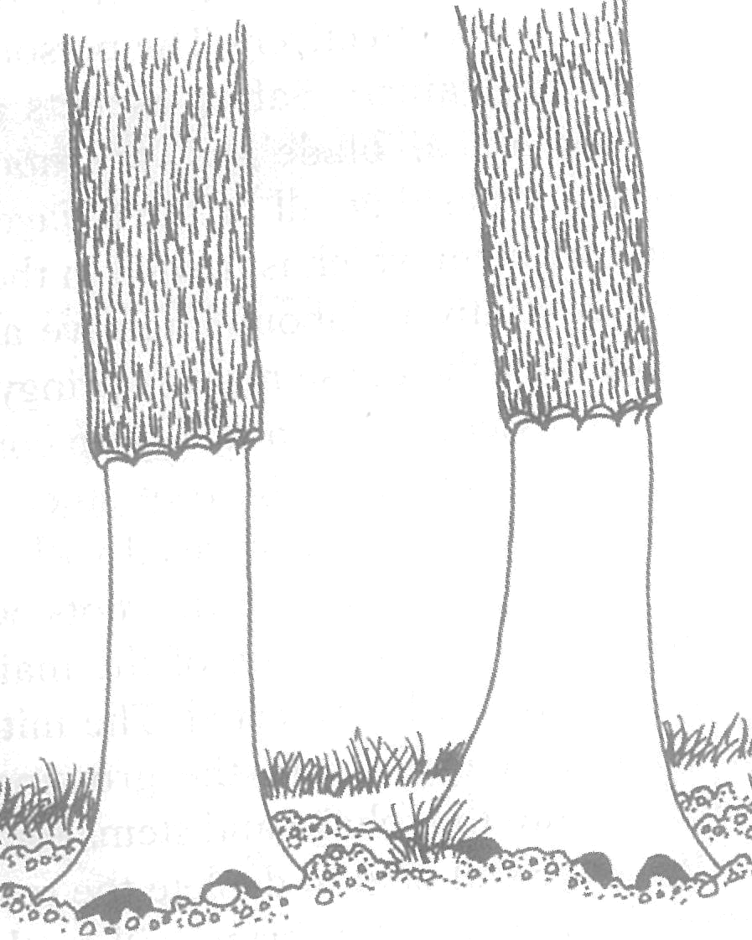  Description | Labour intensive method of killing trees. It is most effective for thin barked species in summer months. e.g. wattle,
 | Most effective if the bark is stripped to below ground level, cutting off light to the remaining cambium surfaces and exposing the root collar.
 | Cuts are made at approximately waist level (1m) around the stem; Bark is then stripped to below ground level.
 | All bark around the stem must be removed; no remaining cambium/phloem should be visible.
 | No herbicide is applied
Tools | Best Practice |  | Most commonly used
Tools | Hatchet |  | Slasher / Bush Knife / Calemba
Potential problems | Varying effectiveness | Poorly supervised and poorly trained workers will result in variable “kill” for target plants.
Potential problems | Multi-stemmed plants | This method is not practical for most multi-stemmed (coppiced) plants as each stem as well as the common stem must be stripped. This is often not possible.
Potential problems | Seasonality | Many species (e.g. wattle) have varying strippability at different times of the year. In winter this method may become more labour intensive and less effective.
Potential problems | Cambium left behind | If the bark does not strip easily, it is very likely that small strips of cambium will remain which will result in the tree recovering, similar to a wound on a human which eventually heals leaving a scar.
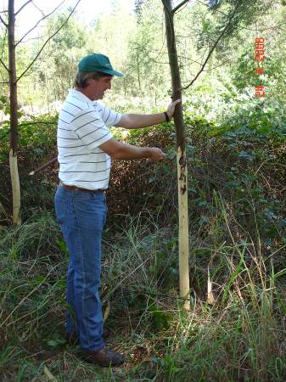
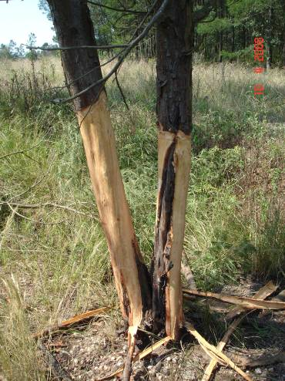
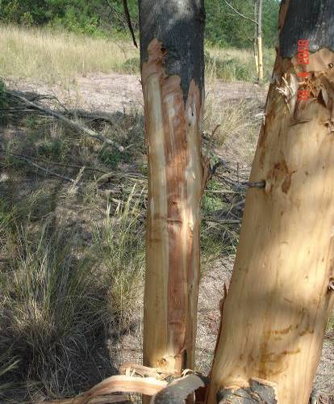

Correct height for an effective strip bark
Multi stem plants are generally not suitable for strip bark treatment as it is difficult to reach the bark between the stems. In this example, a small strip of cambium has remained which will regrow.
Cambium has been left behind on this stem along an old scar, which will regrow and the tree will recover, A more effective option here would have been a cut stump treatment.

Ring bark with herbicide  Stem Diameter >10cm |  |  |  | Chemical
Description | Labour intensive method of killing thick barked trees with systemic herbicide. It is a combination of manual (ring bark) and chemical (frill) methods.
 | As with ring barking, do the bottom cut first. A ring of approx 20cm is required. However, unlike ringbarking, the ring is required as low to the ground as possible. All cambium & phloem layers must be cleaned from this area.
 | Systemic selective herbicide must be applied to the cut surfaces within 15mins of the ring being cut, essential that the person ring barking also applies the herbicide.
 | Using a low pressure hand-sprayer, the herbicide should be applied below the top cut with a solid stream, going around the stem’s circumference twice.
 | This method is better suited to thicker barked species than a frill, however this could differ in different areas and the forester should determine which method is more suitable.
Tools | Best Practice |  | Most commonly used
Tools | Hatchet |  | Slasher / Bush Knife / Calemba
Tools | Low pressure hand held sprayer |  | Paint brush
Potential problems | Varying effectiveness | Poorly supervised and poorly trained workers will result in variable “kill” for target plants.
Potential problems | Poor productivity | Poorly trained workers can strip too large an area away and apply too much herbicide which wastes time and uses too much herbicide. Only a narrow (20cm) strip is required, not 1m.
Potential problems | Multistem species | Not suitable for multistem/coppiced plants – difficult to get an effective ring around all stems and insufficient herbicide is applied.
Potential problems | Cambium left behind | If the ring is too narrow or the bark does not strip easily, it is very likely that small strips of cambium will regrow which will result in the tree recovering, despite herbicide application.

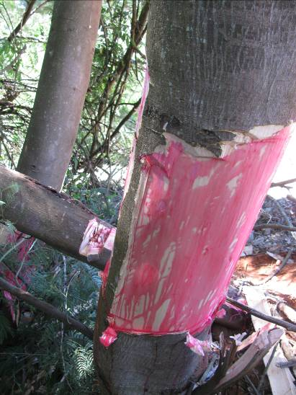
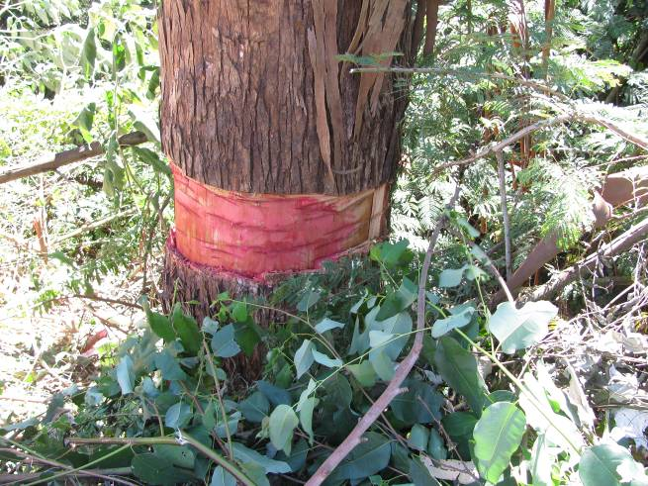
Bark strip which remains will result in recovery of the tree despite herbicide applied. Herbicide has been applied in haphazard way rather than as described above. Strip width is too wide and could be much narrower reducing effort.
Ring barked tree with herbicide applied – however a strip of bark remains at the back of the stem which will result in the tree recovering. The thickness of the bark means a frill application is not suitable for this tree, felling this tree would require a chainsaw operator, if a chainsaw operator is not available, then correct method was used, however the operator requires training.

Spot Spray |  |  |  | Chemical
Description | Specialised labour intensive method of applying selective systemic herbicide to leaf surfaces of target plant.
Description | Only actively growing plants should be sprayed. Plants stressed by frost, heat, drought will not take up sufficient herbicide to result in an effective kill. Generally this means that spraying can only take place in summer months in most areas.
Description | The applicator should start at the growing point of the plant, working down and around the plant with constant pressure. All leaves on the plant should be sprayed.
Description | Good droplet distribution on the leaves is essential and it is recommended that a dye be included in the mixture to assist the operators to achieve this. Spraying to “shiny wet” or “point of runoff” is overkill and will result in excessive herbicide use and require more water to be available infield.
Description | Plants over shoulder height should not be sprayed as it is not possible to reach the growing points and control the spray drift.
Tools | Best Practice |  | Most commonly used
Tools | Pressure regulated knapsack sprayer |  | Non-pressure regulated knapsack sprayers
Tools | Solid cone nozzle pattern |  | Poorly maintained cheap nozzles
Potential problems | Spray drift | Use of non-selective herbicides can result in impact on grass species which is undesirable. OR  Spaying plants over shoulder height
Potential problems | Patchy kill | Incorrect herbicide mix or poor droplet distribution. OR  If plants are over 1m, spot spraying should not be used as the growing point cannot be reached and there non-target plants could be affected. OR  Leaves could be dusty if next to dirt road – this impedes herbicide uptake. These areas should be sprayed after rains or rather make use of cut stump method.
Potential problems | Regrowth after spraying | Many strong suckering or coppicing species (e.g. Grey poplar, bramble) may regrow, It is essential that there is sufficient leaf-area to take up the herbicide to kill the roots, with some species (e.g. bramble) this could be season specific.
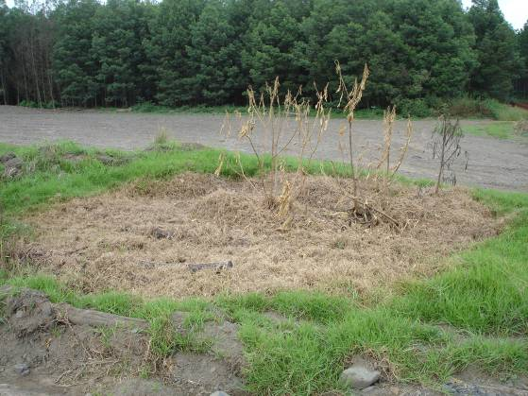
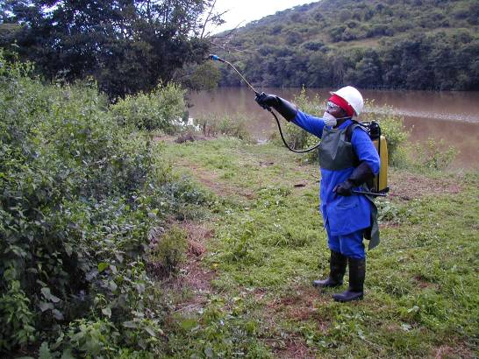
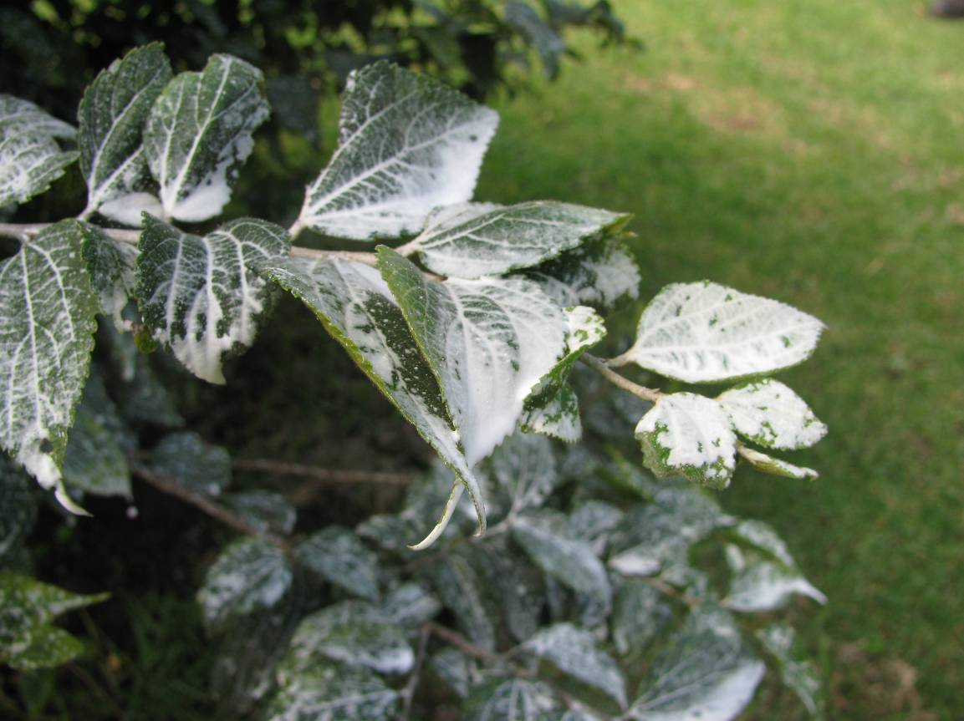
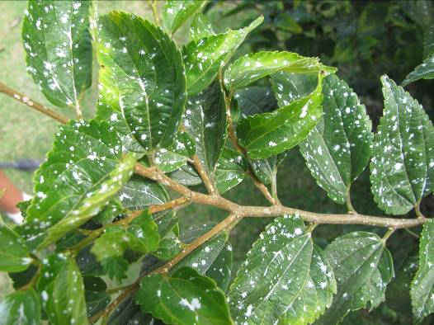
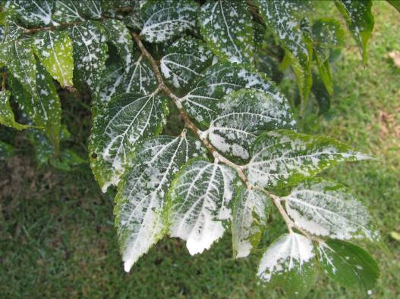
✗
✓
Result of non-selective herbicide use and excessive drift from target plant – possibly due to incorrect nozzle selection
Incorrect use of Knapsack sprayer – the target plant (chomoleana) is too high.
The correct droplet distribution for spot spraying is shown in the picture on the left. The picture on the right shows spot spraying done “to the point of runoff” which is excessive and can result in herbicide use of over 500 litres/ha.

